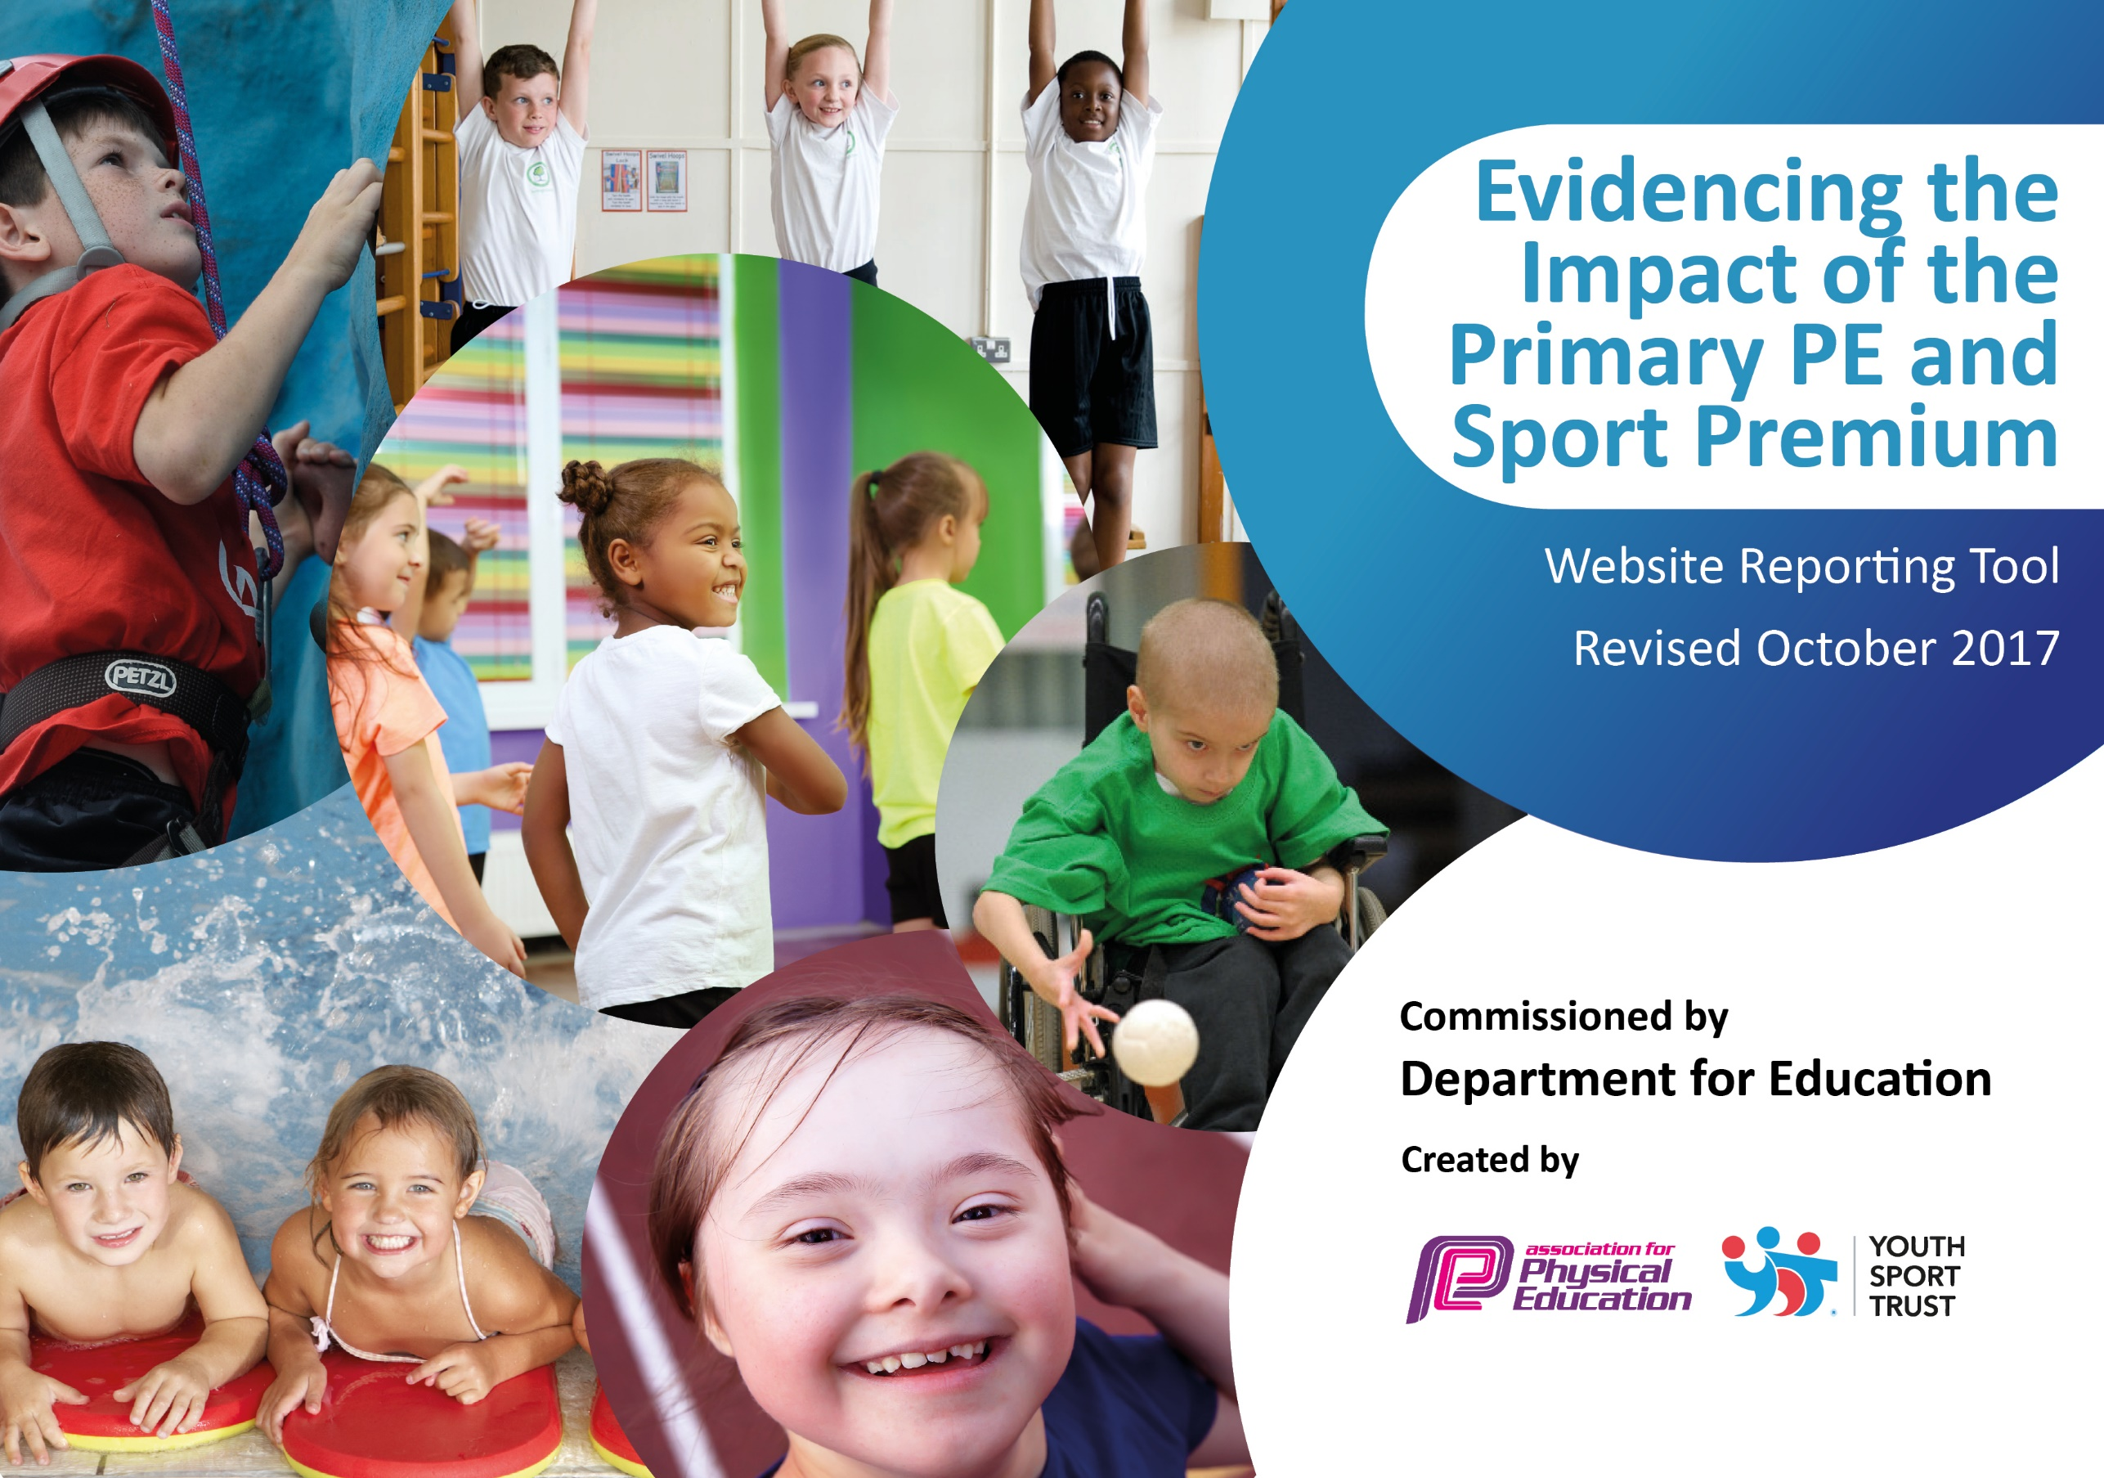

Schools must use the funding to make additional and sustainable improvements to the quality of PE and sport they offer. This means that you should use the Primary PE and Sport Premium to:

- develop or add to the PE and sport activities that your school already offers
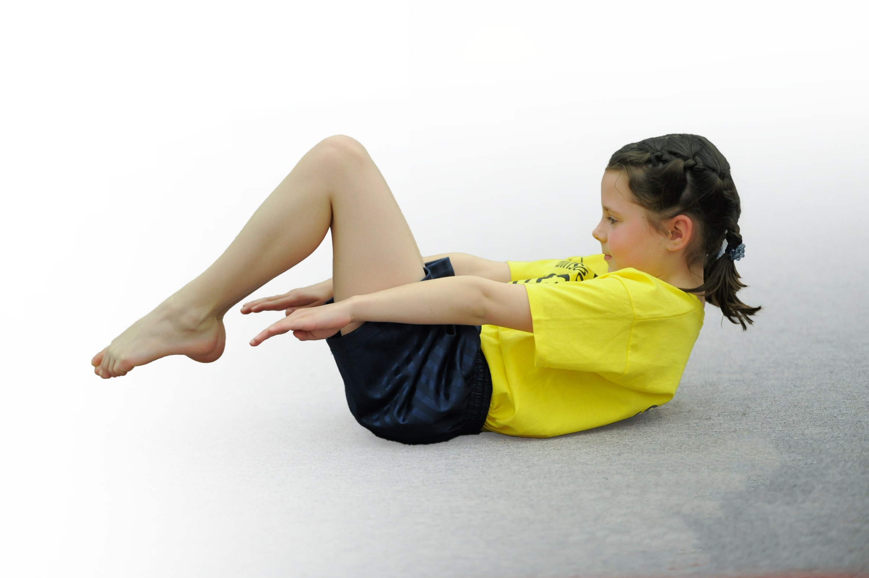
- build capacity and capability within the school to ensure that improvements made now will benefit pupils joining the school in future years

Please visit gov.uk for the revised DfE guidance including the 5 key indicators across which schools should demonstrate an improvement. This document will help you to review your provision and to report your spend. DfE encourages schools to use this template as an effective way of meeting the reporting requirements of the Primary PE and Sport Premium.

We recommend you start by reflecting on the impact of current provision and reviewing the previous spend.
Under the Ofsted Schools Inspection Framework, inspectors will assess how effectively leaders use
the Primary PE and Sport Premium and measure its impact on outcomes for pupils, and how effectively governors hold them to account
for this.

Schools are required to publish details of how they spend this funding as well as on the impact it has on pupils’ PE
and sport participation and attainment.
We recommend regularly updating the table and
publishing it on your website as evidence
of your ongoing review into how you are using the money
to secure maximum, sustainable impact. To see an example of how to complete the table please click HERE.
Support for review and reflection - considering the 5 key indicators from DfE, what development needs are a priority for your setting and your students now and why? Use the space below to reflect on previous spend, identify current need and priorities for the future.

Key achievements to date: | Areas for further improvement and baseline evidence of need:
Hartford Primary School recently achieved a Platinum Award for PE. This means that PE has a high priority in school and that we provide a range of activities for all children to access. Two hours of curriculum PE is provided, the School Sports Organising Crew (SSOC) promote their values in assemblies and through their lunch time competitions, Phys Kids leaders run lunch time activities for younger children, Midday staff have training to enable them to make lunchtimes more active and a wide range of competitions and after-school clubs are successfully attended.  Previous funding has been spent on new equipment to give children access to a wider range of activities such as lacrosse and dodgeball, purchasing a new PE curriculum, training staff to improve the quality of PE lessons and hiring in coaches to work alongside staff. Membership of the Vale Royal School Sports Partnership ensures we have access to high quality training activities and a wide range of competitions for all abilities. | At the start of the year Hartford identified a number of areas which could improve provision further:  Action areas for improvement in the area of SEN to ensure the curriculum and competition offers are inclusive.  Add an element of personal challenge to the competition offer.  Improve activity levels at break times.  Monitor PE lessons to identify the needs of the staff and ensure these needs are met through training.  Offer extra sessions for Gifted and Talented children and any children who are not achieving the expected standard.

Meeting national curriculum requirements for swimming and water safety | Please complete all of the below:
What percentage of your Year 6 pupils could swim competently, confidently and proficiently over a distance of at least 25 metres when they left your primary school at the end of last academic year? | 86%
What percentage of your Year 6 pupils could use a range of strokes effectively [for example, front crawl, backstroke and breaststroke] when they left your primary school at the end of last academic year? | 86%
What percentage of your Year 6 pupils could perform safe self-rescue in different water-based situations when they left your primary school at the end of last academic year? | 0%
Schools can choose to use the Primary PE and Sport Premium to provide additional provision for swimming but this must be for activity over and above the national curriculum requirements. Have you used it in this way? | Yes

Action Plan and Budget Tracking
Capture your intended annual spend against the 5 key indicators. Clarify the success criteria and evidence of impact that you intend to measure to evaluate for students today and for the future.

Academic Year: 2017/18 | Total fund allocated: £19,380 | Date Updated: 3rd April 2018
Key indicator 1: The engagement of all pupils in regular physical activity – Chief Medical Officer guidelines recommend that primary school children undertake at least 30 minutes of physical activity a day in school |  |  |  | Percentage of total allocation:
 |  |  |  | 20%
School focus with clarity on intended impact on pupils: | Actions to achieve: | Funding allocated: | Evidence and impact: | Sustainability and suggested next steps:
A SYCOL group identified the need for school playtimes to be more active. Pupil voice was used for ideas to make this happen. Mr. Cairns, PE coordinator, identified the need for PE lesson and other parts of the school day to become more active. The aim was to provide all children with at least 30 minutes of activity in school every day. | Purchase Maths of the Day to improve activity levels in maths.  Continue to subscriber to 5 a day fitness, GoNoodle, Cosmic Kids Yoga and Super Movers and monitor their use.  Pupil voice identified the need for one of our pens to have activities other than football. Purchase basketball nets and develop a skipping and dance area.  Attend training and register with active planner.  Monitor activity levels in PE lessons and provide training to improve this area. | £495  £200  £2770  £105  £350 | Maths of the Day purchased and has led to maths lessons becoming more active. An active maths lesson has to take place at least every other week. Ideas from these lessons have led to other sessions being more active in their learning.  Monitoring is ongoing to track activity level in classes using 5 a day fitness etc. Every class in school is now more active than last year.  Basketball nets are being built in May. Dance and skipping areas will be in place in April. The impact of these areas on activity levels at break times will then be undertaken.  Mr. Cairns went to training and registered and active planner. This led to the improvement mentioned above.  Mr. Cairns monitored activity levels in PE lesson in the Autumn Term and training was provided. A further set of observations will take place in the Summer Term to monitor the effectiveness of the training. | Look for further ways to make lessons in other subjects more active.  Think of ways to ensure all staff are effectively accessing 5 a day etc so every child is getting equal access to them.  Monitor the effectiveness of new playground equipment on activity levels during breaks. Use Pupil Voice to continually monitor and improve the playground.
Key indicator 2: The profile of PE and sport being raised across the school as a tool for whole school improvement |  |  |  | Percentage of total allocation:
 |  |  |  | 17%
School focus with clarity on intended impact on pupils: | Actions to achieve: | Funding allocated: | Evidence and impact: | Sustainability and suggested next steps:
PE has always been held in high regard at Hartford Primary School. This year we wanted it to start to have more of an impact across different areas of school.  Offer further activities for G&T children and those not meeting the expected standard in PE.  The SSOC wanted to ensure their values are promoted in everything they do.  Mr. Cairns wanted to ensure the profile of PE was kept high by spending time ensuring the school received and promoted their Platinum Award. | Identify children who are regularly late to school and always miss their start of the day activity. Hire Mrs. Middlebrook to run a breakfast club for them to attempt to improve their attendance.  Mrs. Middelbrook to work in school every Friday with different groups identified by Mr. Cairns.  Run lunch time and after-school club sessions for the SSOC so they can plan their assemblies and activities and promote their values across the school. Athlete visits planned to promote sport.  PE coordinator to have enough time to achieve the Platinum Award. | £3070  £105  £210 | Mrs. Middlebrook now works every Friday in school. This means all G&T children have extra sessions and those identified as not meeting the expected standard.  Breakfast club has only run for one ½ term. Some children in the club have now done their morning task in class, something they have never achieved before.  The SSOC have run assemblies and activities promoting their values. 75% of children have attended a lunch time phys kids club or competition.  The school achieved the Platinum Award and has promoted this to all parents and the wider community. Jenna Downing, a World Champion in-line skater, presented the award to Mr. Cairns. | Funding for Mrs. Middlebrook to continue to ensure groups identified continue to make progress. Ensure assessment systems in PE are accurate and robust enough to ensure the correct children are targeted and their improvements can be tracked.  PE coordinator to have help from another member of staff next year to ensure the wide range of activities can continue and a transition plan is in place if any staff changed coordinator roles.

Key indicator 3: Increased confidence, knowledge and skills of all staff in teaching PE and sport |  |  |  | Percentage of total allocation:
 |  |  |  | 10%
School focus with clarity on intended  impact on pupils: | Actions to achieve: | Funding  allocated: | Evidence and impact: | Sustainability and suggested  next steps:
Children at Hartford Primary School have one PE lesson with Mr. Cairns and one with their class teacher. The focus this year was to ensure class teachers have increased confidence, knowledge and skills to ensure all lesson are at least good with some outstanding. | Monitor PE lessons in the Autumn Term with a focus on issues identified in discussions with staff. Training then provided by Mr. Cairns to work on areas identified as needing improvements.  Training courses run by Vale Royal School Sports Partnership offered to staff.  Coaches sourced to work alongside staff in cricket and gymnastics. | £350  £1000  £640 | Lessons were observed by Mr. Cairns. Ways to improve across were identified and three staff meetings were planned in across the year to work on these areas.  Further observations are planned in the Summer Term and a staff questionnaire to check the impact of the training.  Cricket and gymnastics co-delivery is also planned for the Summer Term. | These cycles of observations and membership of the VRSSP will continue to ensure all staff have access to training and the quality of PE lessons can continue to improve.
Key indicator 4: Broader experience of a range of sports and activities offered to all pupils |  |  |  | Percentage of total allocation:
 |  |  |  | 9%
School focus with clarity on intended  impact on pupils: | Actions to achieve: | Funding  allocated: | Evidence and impact: | Sustainability and suggested  next steps:
This is not an area that Hartford Primary School needed to focus on this year. We offer curriculum PE in a wide range of activities from dance and gymnastics through traditional sports such as football to dodgeball, lacrosse and orienteering.  After-school clubs also include activities including fencing and judo. Competitions are offered in many sports and include every child in Y5 & 6 as well as a number of competitions for Y1-4. | Buy handballs as handball is a new sport in The PE Hub curriculum.  Purchase yoga mats so this can be a new after-school club.  Subscribe to The PE Hub curriculum.  Continue with the range of sports already on offer.  Pay for after-school clubs to ensure every child has access to a free club. | £100  £100  £350  £1200 | Handballs were purchased and a number of year groups offered handball as a new sport this year.  Yoga mats were purchased and a yoga and mindfulness after-school club ran.  The PE Hub online PE curriculum was purchased. This ensures the planning for every PE lesson in school is of a consistent quality.  A wide-range of after-school clubs were on offer with the aim of 100% of children attending a sports club. Monitoring is ongoing to attempt to achieve this target through Pupil Voice. | Equipment is continually assessed and this will continue.  The PE curriculum subscription will be purchased every year.  The PE coordinator will continue to use Pupil Voice to ensure the activities on offer at Hartford Primary School match the needs of the children and staff.
Key indicator 5: Increased participation in competitive sport |  |  |  | Percentage of total allocation:
 |  |  |  | 22%
School focus with clarity on intended  impact on pupils: | Actions to achieve: | Funding  allocated: | Evidence and impact: | Sustainability and suggested  next steps:
Hartford enter every competition on offer and are very successful. We ensure that every child leaves school having entered at least 6 competitions and are prepared for them when they attend. Gifted and Talented children attend competitions with a pathway into County Finals. Funding for these will continue. | Continue with the competitive sport already on offer. Add personal challenge and competitions for SEN into the program.  Continue membership of the VRSSP.  Pay supply and travel costs for competitions. | £2000  £2285 | 100% of children in KS2 have attended a competition.  County Finals have been reached in girls football, indoor athletics and tag rugby.  A boccia tournament was entered and the children who attended gained a lot from it. A pathway into a SEN out of school club was offered after the competition.  Supply costs are paid to ensure Mr. Cairns can attend competitions with the children. This ensures that the children are well prepared for competitions and have a positive experience whilst they are there. | The very successful competition program will continue.  Ways to engage the least active children will regularly be sourced to ensure every child has access to a competition program which is right for them.

